3 Marks
1. Non-ideal solution exhibit either positive or negative deviations from Raoult’s law. What are these deviations and why are the caused? Explain with one example for each type.
2.a) Why is an increase in temperature observed on mixing chloroform and acetone?
b) Why does sodium chloride solution freeze at a lower temperature than water?
3. A Solution of glycerol (C₃H₈0₃) in water was prepared by dissolving some glycerol in 500g of water. This solution has a boiling point of 100.42C while pure water boils at 100-C. What mass of glycerol was dissolved to make the solution?
4. Determine the amount of CaCl₂ (i=2.47) dissolved in 2.5 litre of water such that is osmotic pressure is 0.75 ATM at 27⁰C
5. The molar freezing point of depression constant for benzene is 4.90Kgmol⁻¹. Selenium exists as polymer Se. When 3.26gm if Seis dissolved in 226 gm of benzene, the observed freezing point is 0.1127 lower than for pure benzene. Decide the molecular formula of selenium

5 Marks
1. a) State Raoult’s Law for a solution containing volatile components. How does Raoult’s law become a special case of henry’s law
b) 1.00g of a non-electrolyte solute dissolved in 50g of benzene lowered the freezing point of a benzene is 0.40K. Find the molar mass of the solute.
2. Calculate the molarity of a sulphuric acid solution in which the mile fraction of water is 0.85.
Composition is given alongside.
i) Are the A-B intersections weaker, stronger of the same magnitude as A-A and B-B
ii) Name the type of deviation shown by this system from Raoult’s Law.
iii) Predict the sign of Δ_{Mix}H for this system
iv) Predict the sign of Δ_{Mix}V for this system.
v) Give an example of such system.
vi) What is the azeotrope will this system form, if possible?
3 Marks
1. Determine the value of equilibrium constant and ΔG⁰ for the following reaction:
Ni(S)+2Ag⁺(aq) →Ni²⁺(aq) +2Ag(S) (E⁰=1.05V)
2. Calculate the standard electrode potential of Ni²⁺//Ni electrode if emf of the Ni²⁺//Ni (0.01) // CU²⁺(0.1)/Cu(s) electrochemical cell is 0.059V. Given E⁰=0.34 V
3. The resistance of conductivity cell filled with 0.1 M KCI solution is 100 Ohm. If the resistance in the same cell when filled with 0.02 M KCI solution is 520 ohm, calculate the conductivity and molar conductivity 0.02 M KCI solution. Conductivity of 0.1 M KCI solution is 1.29 m⁻¹
4. Give an example of a fuel cell and write the cathode and anode reaction for it.

5 Marks
1. i) Define the molar conductivity of a solution and explain how molar conductivity changes with change in concentration of solution for a weak and strong electrolyte.
ii) The resistance of a conductivity cell containing 0.001KMCI solution at 298K is 15000.
What is the cell constant, if the conductivity of 0.01MKCI solution at 298K is?

2. i) Write the formulation for galvanic cell in which the reaction
Cu(s) + 2Ag⁺(aq) → Cu²⁺ (aq) + 2Ag(s)
Takes place, identify the cathode and the anode reaction in it.
ii) Write Nernst equation. Calculate the emf of the following cell:
Sn(s)/Sn²⁺(0.04M)//H⁺(0.02M)H₂(g),Pt(s) (Given E⁰Sn²⁺/Sn=0.14v)

3 Marks
1. Show that in a first order reaction, time required for completion of 99.9% is 10 times of half life (t_{1/2}) of the reaction.
2. The rate constants of a reaction at 500K and 700K are 0.02s⁻¹ and 0.07s⁻¹ respectively. Calculate the values of E_{a} and A.
3. A first order reaction takes 40 min for 30% decomposition. Calculate t_{1/2+}
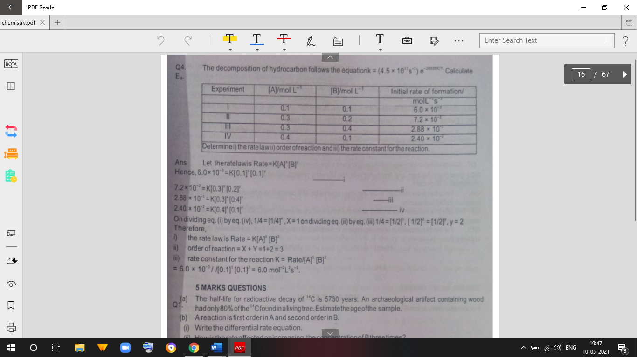
4. The decomposition of hydrocarbon follows the equation k= (4.5*10¹¹s⁻¹) e^{-28000k} Calculate

